**Introduction**

**Problem Statement –**

Develop a basic understanding of risk analytics in banking and financial services and understand how data is used to minimise the risk of losing money while lending to customers.

**Solution –**

With our dashboards which are created using Power BI latest tools helps the company to make a decision based on the applicant’s profile like if the applicant is likely to repay the loan then approving the loan otherwise not.

**Tools used –**

1. Power BI
2. MySQL
3. Excel
4. Python

**About the Dataset**

**Table: Customer Financial Profile**

This dataset captures individual-level financial and demographic information, including income, credit cards, loans, deposits, and customer classification. Each row represents one customer.

**Key Columns Summary**

|  |  |
| --- | --- |
| Column | Description |
|  |  |
| Loyalty Classification | Customer tier (e.g., Jade, Gold, etc.) |
| Estimated Income | Annual income of the customer |
| Superannuation Savings | Retirement/pension savings |
| Amount of Credit Cards | Number of credit cards held |
| Credit Card Balance | Total credit card debt |
| Bank Loans | Total value of loans |
| Bank Deposits | Total deposits across all accounts |

**Implied Relationships**

Although only one table is given, the following columns likely link to reference tables:

* BRId → Bank Branch Table
* GenderId → Gender Lookup Table
* IAId → Internal Account/Customer Table

**ER Diagram**

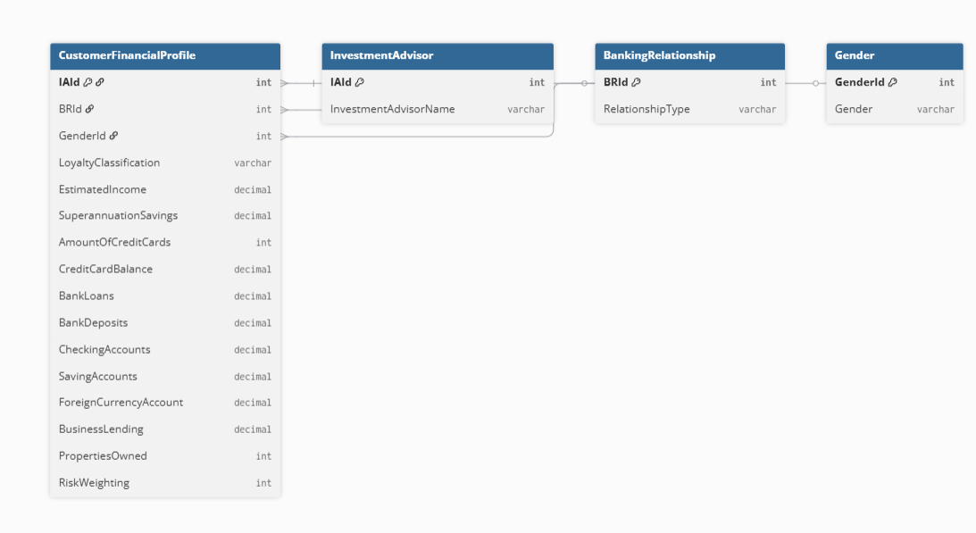

### ****ER Diagram Explanation****

* **CustomerFinancialProfile** is the **main table** containing detailed financial data for each customer.
* It connects to **three lookup tables** using foreign keys:
  + IAId → links to **InvestmentAdvisor** (shows which advisor manages the customer)
  + BRId → links to **BankingRelationship** (shows the type of banking segment: Retail, Commercial, etc.)
  + GenderId → links to **Gender** (stores the gender of the customer)
* **InvestmentAdvisor** table holds the names of financial advisors.
* **BankingRelationship** table defines the type of banking relationship (e.g., Retail, Private Bank).
* **Gender** table stores gender info (e.g., Male, Female).
* Arrows (lines) between tables represent **relationships** (foreign keys connecting to primary keys).
* This ERD supports customer profiling, advisor assignment, and segmentation by banking and gender types.

**Data Cleaning –**

Creating a new column Engagment Days in Client-Banking table how many days the client spent from the date of joining in banks

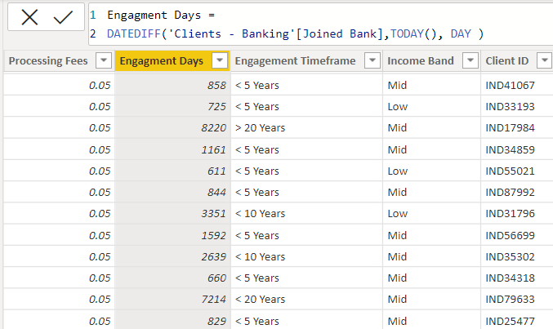

Creating a new column Engagement Timeframe in client-banking column which tells about the time line of the clients in banks

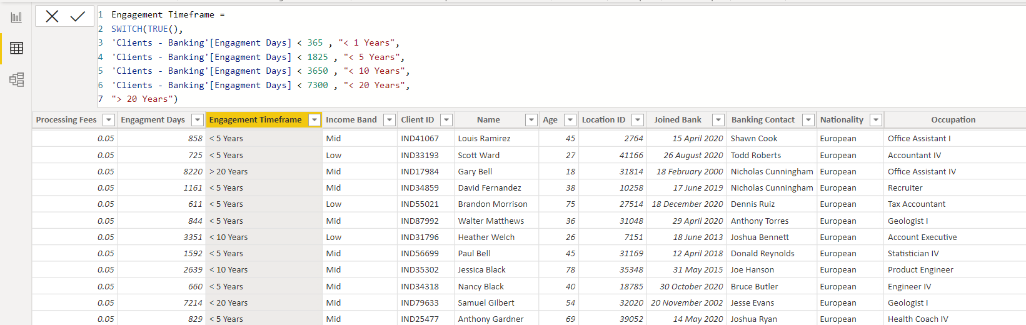

Creating bins for the Estimated Income < 100000 as low and <300000 as Mid with the column named as Income Band in Clients-Banking table.

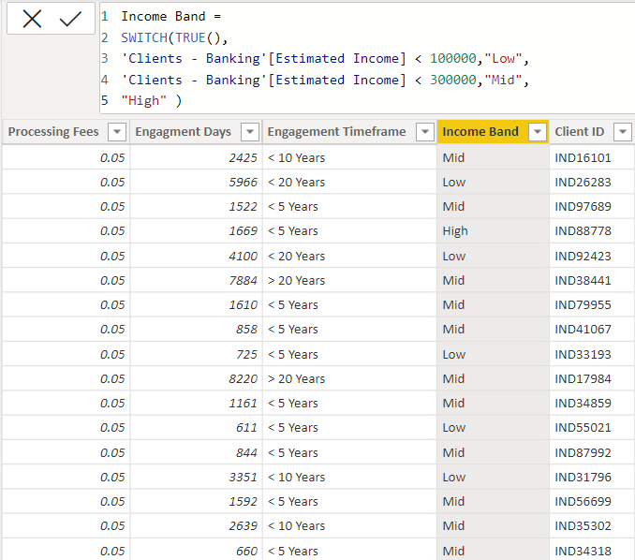

Creating a new column named as Processing Fees for the column Fee Structure like if fee structure is high then processing fee would be 0.05

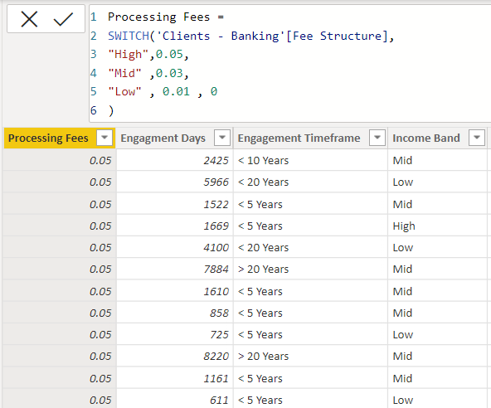

**Measures in Power BI**

**Sum :**

The power bi sum function will add all the numbers in a column and the column contains numbers to sum. It returns a decimal number.

**Syntax :**

Sum= SUM(<column>)

Example:

Bank Deposit =

SUM('banking-clients'[Bank Deposits] )

**DistinctCount :**

Counts the number of distinct values in a column

Syntax:

DISTINCTCOUNT(<column>)

Example :

Total Clients = DISTINCTCOUNT('banking-clients' [Client ID] )

**Sumx :**

Returns the sum of an expression evaluated for each row in a table.

Syntax:

SUMX(<table>, <expression>)

Example :

Total Fees = SUMX('banking-clients', [Total Loan] * 'Clients - Banking'[Processing Fees] )

**Switch :**

Evaluated an expression against a list of values and returns one of multiple possible result expressions

Syntax :

SWITCH(<expression>, <value>, <result>[, <value>, <result>]…[, <else>])

**DATEDIFF :**

Returns the number of interval boundaries between two dates.

Syntax :

DATEDIFF(<Date1>, <Date2>, <Interval>)

Example :

Engagment Days = DATEDIFF('banking-clients' [Joined Bank],TODAY(), DAY )

**KPI’S:**

In which followings KPIS are present :

**Total Clients :**

Total Clients KPI represents total number of clients in banking.

Total Clients = DISTINCTCOUNT('banking-clients' [Client ID] )

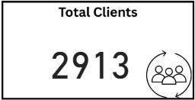

**Total Loan :**

Total Loan gives you information about the bank loan + Business lending + credit cards balance of particular investor , gender.

Total Loan = [Bank Loan] + [Business Lending] + [Credit Cards Balance]

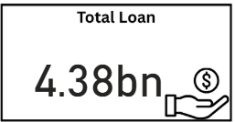

**Bank Loan :**

Bank Loan gives you information what is the loan amount of loan to be repaid by the client to bank.

Bank Loan = SUM('banking-clients' [Bank Loans] )

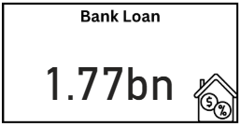

**Business Lending :**

Business lending gives you information about the loan amount given to small business.

Business Lending = SUM('banking-clients' [Business Lending] )

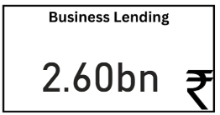

**Total Deposit**

Total Deposit gives you information about the amount deposited by particular investors in bank

Total Deposit = [Bank Deposit] + [Savings Account] + [Foreign Currency Account] + [Checking Accounts]

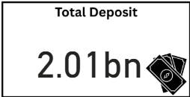

**Total Fees :**

Total Fees is nothing but the amount charged by the bank for account set-up , maintenance charges etc.

Total Fees = SUMX('banking-clients', [Total Loan] * 'Clients - Banking'[Processing Fees] )

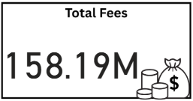

**Checking Account Amount :**

Checking account amount is nothing but which offers easy access to your money for daily transactional needs.

Checking Accounts =

SUM('banking-clients' [Checking Accounts] )

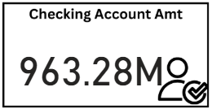

**Total CC Amount :**

Total CC Amount is a short-term source of financing for a company by a bank.

Total CC Amount = SUM('banking-clients' [Amount of Credit Cards] )

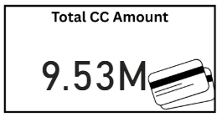

**Saving Account Amount :**

A savings account is an interest-bearing deposit account held at a bank.

Savings Account = SUM('banking-clients' [Saving Accounts] )

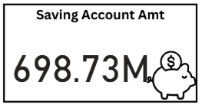

**Foreign Currency Amount :**

Foreign Currency Account means an account held in a currency that is not the currency of India or Bhutan or Nepal.

Foreign Currency Account =

SUM('banking-clients' [Foreign Currency Account] )

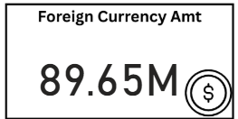

**Visualization And Result –**

**Home**

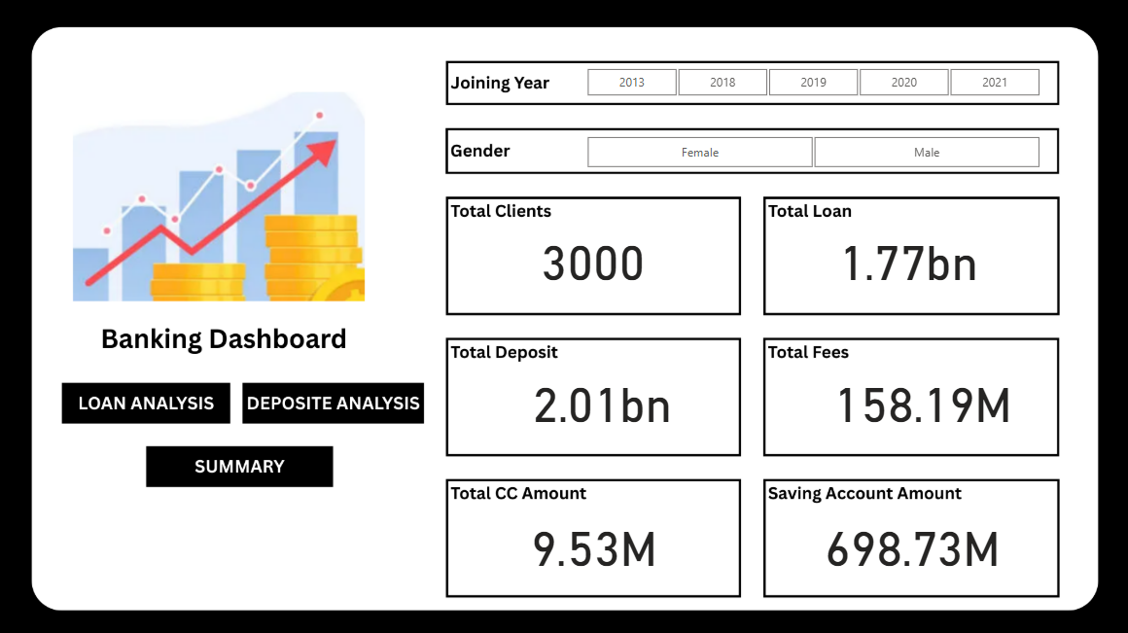

**Loan Analysis**

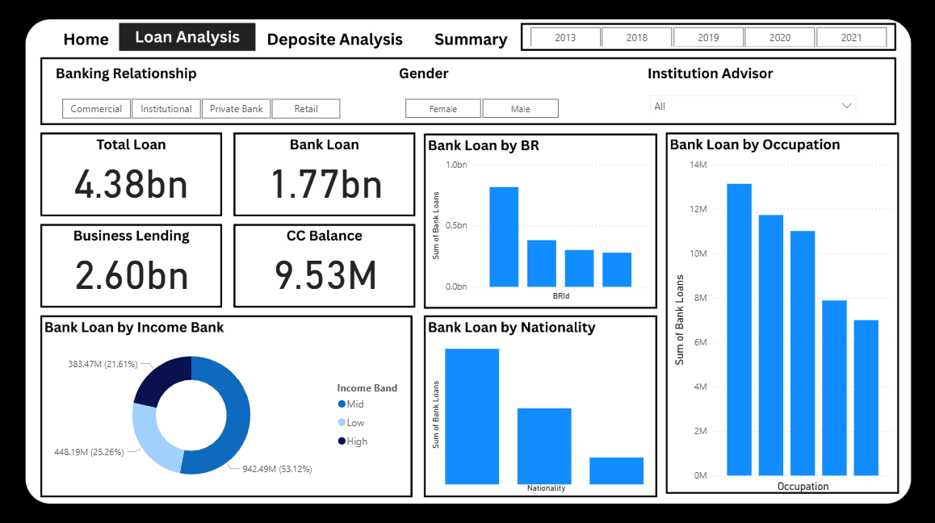

**Deposit Analysis**

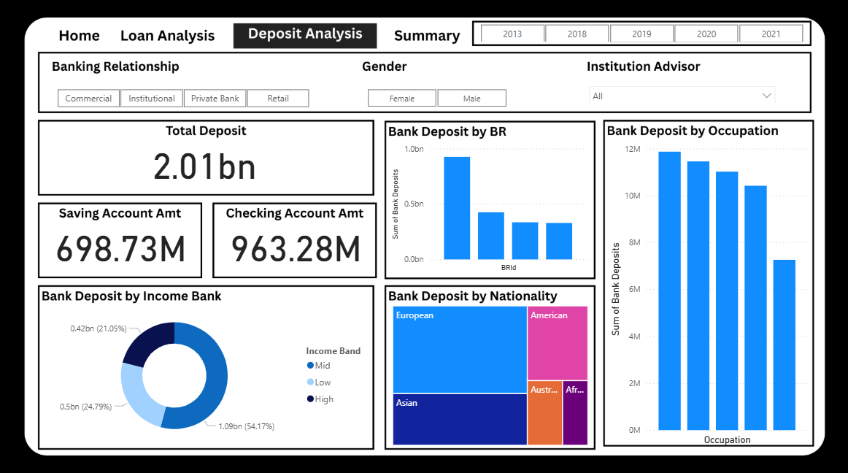

**Summary Dashboard**

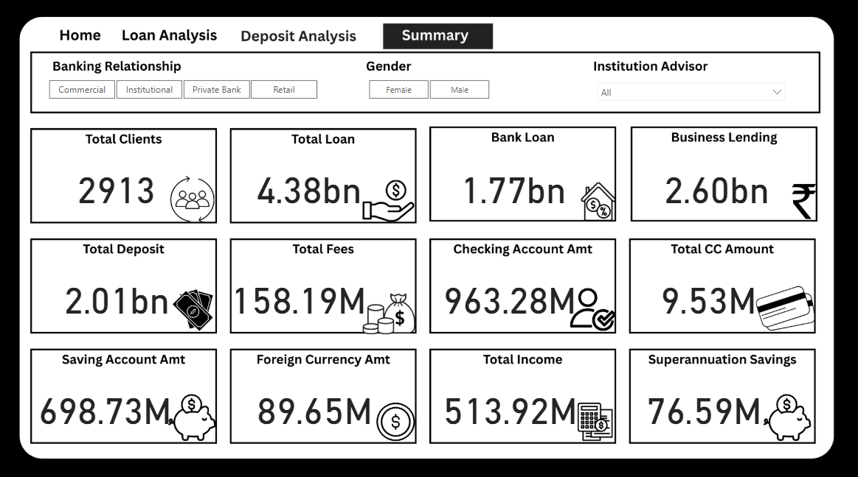

**Conclusion –**

Empowered by the latest data visualization techniques, Power BI dashboards are among the most effective resources for using in banking sector. As outlined in this write-up, a banking operations dashboard in Power BI can be developed with key banking related metrics and KPIs.

**Future Work –**

* **Investor Loan Overview:**  
  Banks can easily access the total loan amount and other financial details associated with individual investors, facilitating efficient portfolio management.
* **Client Distribution by Bank Type:**  
  The data reveals that **private banks** have a higher number of clients compared to other bank types. This insight can guide public or international banks in developing targeted strategies to attract and retain more clients.
* **Nationality-Based Loan Analysis:**  
  The dashboards identify which **nationalities hold the highest loan amounts**, offering valuable demographic insights for risk assessment and product targeting.
* **Account Type & Investment Patterns:**  
  The analysis also highlights the distribution of investment amounts across various account types, helping banks understand investor behavior and optimize their service offerings.